Introduction to Machine Learning
- Machine learning (ML) allows computers to learn and make decisions without being explicitly programmed.
- It involves feeding data into algorithms to identify patterns and make predictions on new data.
- It is used in various applications like image recognition, speech processing, language translation, recommender systems, etc.

Why do we need Machine Learning?
- Traditional programming requires exact instructions and doesn’t handle complex tasks like understanding images or language well.
- It can’t efficiently process large amounts of data.
- Machine Learning solves these problems by learning from examples and making predictions without fixed rules.

Let's see various reasons why it is important:

1. Solving Complex Business Problems
Traditional programming struggles with tasks like language understanding and medical diagnosis. ML learns from data and predicts outcomes easily.
Examples:
- Image and speech recognition in healthcare.
- Language translation and sentiment analysis.

2. Handling Large Volumes of Data
The internet generates huge amounts of data every day. Machine Learning processes and analyzes this data quickly by providing valuable insights and real-time predictions.
Examples:
- Fraud detection in financial transactions.
- Personalized feed recommendations on Facebook and Instagram from billions of interactions.

3. Automate Repetitive Tasks
ML automates time-consuming, repetitive tasks with high accuracy hence reducing manual work and errors.
Examples:
- Gmail filtering spam emails automatically.
- Chatbots handling order tracking and password resets.
- Automating large-scale invoice analysis for key insights.

4. Personalized User Experience
ML enhances user experience by tailoring recommendations to individual preferences. It analyze user behavior to deliver highly relevant content.
Examples:
- Netflix suggesting movies and TV shows based on our viewing history.
- E-commerce sites recommending products we're likely to buy.

5. Self Improvement in Performance
ML models evolve and improve with more data helps in making them smarter over time. They adapt to user behavior and increase their performance.
Examples:
- Voice assistants like Siri and Alexa learning our preferences and accents.
- Search engines refining results based on user interaction.
- Self-driving cars improving decisions using millions of miles of driving data.

What Makes a Machine "Learn"?
A machine "learns" by identifying patterns in data and improving its ability to perform specific tasks without being explicitly programmed for every scenario.
This learning process helps machines to make accurate predictions or decisions based on the information they receive.
Unlike traditional programming where instructions are fixed, ML allows models to adapt and improve through experience.
Here is how the learning process works:
- Data Input: Machine needs data like text, images or numbers to analyse. Good quality and enough quantity of data are important for effective learning.
- Algorithms: Algorithms are mathematical methods that help the machine find patterns in data. Different algorithms help different tasks such as classification or regression.
- Model Training: During training, the machine adjusts its internal settings to better predict outcomes. It learns by reducing the difference between its predictions and actual results.
- Feedback Loop: Machine compares its predictions with true outcomes and uses this feedback to correct errors. Techniques like gradient descent help it update and improve.
- Experience and Iteration: Machine repeats training many times with data helps in refining its predictions with each pass, more data and iterations improve accuracy.
- Evaluation and Generalization: Model is tested on unseen data to ensure it performs well on real-world tasks.
Machines "learn" by continuously increasing their understanding through data-driven iterations like how humans learn from experience.

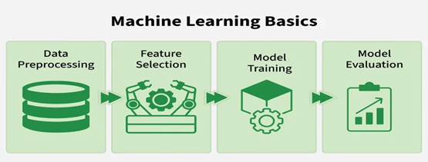

- The machine collects data - Data Acquisition
- It analyses the data to find patterns - Data Exploration
- It tries out different solutions - Solution Modeling
- Receives feedback and figures the best out of them - Evaluation
- It implements the optimal solution - Deployment

Importance of Data in Machine Learning

Data is the foundation of machine learning (ML) without quality data ML models cannot learn, perform or make accurate predictions.
- Data provides the examples from which models learn patterns and relationships.
- High-quality and diverse data improves how well models perform and generalize to new situations.
- It helps models to understand real-world scenarios and adapt to practical uses.
- Features extracted from data are important for effective training.
- Separate datasets for validation and testing measure how well the model works on unseen data.
- Data drives continuous improvements in models through feedback loops.

Types of Machine Learning
There are three main types of machine learning which are as follows:
1. Supervised learning
Supervised learning trains a model using labeled data where each input has a known correct output. The model learns by comparing its predictions with these correct answers and improves over time. It is used for both classification and regression problems.
Example: Consider the following data regarding patients entering a clinic. The data consists of the gender and age of the patients and each patient is labeled as "healthy" or "sick".
Gender | Age | Label
M | 48 | sick
M | 67 | sick
F | 53 | healthy
M | 49 | sick
F | 32 | healthy
M | 34 | healthy
M | 21 | healthy
In this example, supervised learning is to use this labeled data to train a model that can predict the label ("healthy" or "sick") for new patients based on their gender and age. For example if a new patient i.e Male with 50 years old visits the clinic, model can classify whether the patient is "healthy" or "sick" based on the patterns it learned during training.
2. Unsupervised learning:
Unsupervised learning works with unlabeled data where no correct answers or categories are provided. The model's job is to find the data, hidden patterns, similarities or groups on its own. This is useful in scenarios where labeling data is difficult or impossible. Common applications are clustering and association.
Example: Consider the following data regarding patients. The dataset has a unlabeled data where only the gender and age of the patients are available with no health status labels.
Gender | Age
M | 48
M | 67
F | 53
M | 49
F | 34
M | 21
Here unsupervised learning looks for patterns or groups within the data on its own. For example it might cluster patients by age or gender and grouping them into categories like "younger healthy patients" or "older patients" without knowing their health status.
3. Reinforcement Learning
Reinforcement Learning (RL) trains an agent to make decisions by interacting with an environment. Instead of being told the correct answers, agent learns by trial and error method and gets rewards for good actions and penalties for bad ones. Over time it develops a strategy to maximize rewards and achieve goals. This approach is good for problems having sequential decision making such as robotics, gaming and autonomous systems.
Example: While Identifying a Fruit, system receives an input for example an apple and initially makes an incorrect prediction like "It's a mango". Feedback is provided to correct the error "Wrong! It's an apple" and the system updates its model based on this feedback.
Over time it learns to respond correctly that "It's an apple" when getting similar inputs and also improves accuracy.
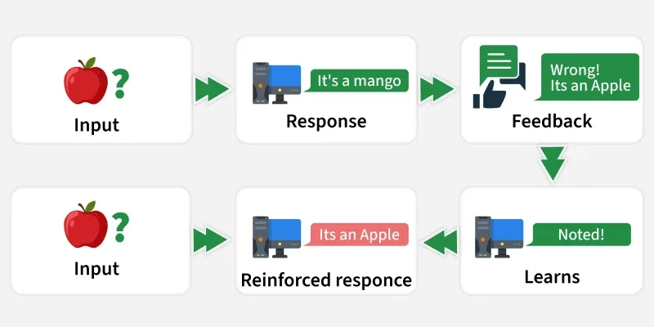
Reinforcement Learning

Besides these three main types, modern machine learning also includes two other important approaches: Self-Supervised Learning and Semi-Supervised Learning.

Benefits of Machine Learning
- Enhanced Efficiency and Automation: ML automates repetitive tasks, freeing up human resources for more complex work. This leads to faster, smoother processes and higher productivity.
- Data-Driven Insights: It can analyze large amounts of data to identify patterns and trends that might be missed by people and help businesses make better decisions.
- Improved Personalization: It customizes user experiences by tailoring recommendations and ads based on individual preferences.
- Advanced Automation and Robotics: It helps robots and machines to perform complex tasks with greater accuracy and adaptability. This is transforming industries like manufacturing and logistics.
Challenges of Machine Learning
- Data Bias and Fairness: ML models learn from training data and if the data is biased (systematic errors or imbalances within a dataset that lead to skewed, unrepresentative, or unfair conclusion), model’s decisions can be unfair so it’s important to select and monitor data carefully.
- Security and Privacy Concerns: Since it depends on large amounts of data, there is a risk of sensitive information being exposed so protecting privacy is important.
- Interpretability and Explainability: Complex ML models can be difficult to understand which makes it difficult to explain why they make certain decisions. This can affect trust and accountability.
- Job Displacement and Automation: Automation may replace some jobs so retraining and helping workers learn new skills is important to adapt to these changes.

Applications of Machine Learning
Machine Learning is used in many industries to solve problems and improve services. Here are some common real-world applications:
- Healthcare: It helps doctors to diagnose diseases from medical images like X-rays and MRIs. It also predicts patient outcomes and personalizes treatments which improves healthcare quality.
- Finance: In finance it detects fraudulent transactions in real time and supports algorithmic trading. It also helps to assess credit risk helps in making lending safer and faster.
- Retail and E-Commerce: It helps in personalized product recommendations and forecasts demand to optimize inventory and also analyzes customer sentiment to improve shopping experiences.
- Transportation and Automotive: Self-driving cars rely on ML to navigate and make decisions. It optimizes delivery routes and predicts vehicle maintenance needs which reduces downtime.
- Social Media and Entertainment: Platforms like Netflix and YouTube use ML to recommend content we'll enjoy. It enables image and speech recognition for better user interaction.
- Manufacturing: It improves quality control by detecting defects in products automatically and predicts machine failures in advance and helps in production processes.

Hypothesis space
In machine learning, the hypothesis space ($H$) is the set of all possible functions (hypotheses or models) that a learning algorithm can choose from to approximate a target function.
The algorithm's goal is to search this space to find the best possible hypothesis that maps input data to output predictions effectively and generalizes well to unseen data.
Core Concepts
- Hypothesis (ℎ): A single candidate function that maps input features to predicted outputs ($h∶X→Y$).
- Target Function ($f$): The ideal, often unknown, true relationship between inputs and outputs that the machine learning algorithm aims to approximate.
- Learning Process: Machine learning is essentially a search through the hypothesis space to find the specific $h∈H$that best fits the training data and generalizes to unseen examples.

Key Concepts A
- Hypothesis (h): A single candidate function or model selected from the hypothesis space. For a linear regression model, a specific hypothesis might be a function like
$y=2x+3$.
- Target Function (f): The true, unknown function that the machine learning algorithm is attempting to discover or approximate from the data.
- Learning as Search: The process of training a machine learning model is essentially a search through the hypothesis space to find the hypothesis that minimizes a predefined error or loss function (e.g., Mean Squared Error or Cross-Entropy Loss).

Types of Hypothesis Spaces
There are two main types of hypothesis spaces:
1. Discrete Hypothesis Space
2. Continuous Hypothesis Space
• Discrete Hypothesis Space: Contains a finite or countably infinite number of hypotheses. Example: Decision trees with a fixed depth.
• Continuous Hypothesis Space: Contains an uncountably infinite number of hypotheses. Example: Linear regression models with real-valued coefficients.

Importance
The definition and size of the hypothesis space are crucial considerations in model design, directly impacting the learning outcome.
- Underfitting (Small Hypothesis Space): If the hypothesis space is too restricted or simple (e.g., using a linear model for highly non-linear data), it may not contain a function that can adequately capture the underlying patterns in the data. This leads to high bias and poor performance on both training and test data.
- Overfitting (Large Hypothesis Space): Conversely, a very large and complex hypothesis space (e.g., a deep neural network with too many parameters for the available data) offers flexibility but increases the risk of the model memorizing the noise in the training data rather than the general patterns. This leads to high variance and poor generalization to new data.

Significance
The size and complexity of the hypothesis space significantly impact model performance:
- Expressiveness: A larger hypothesis space is more flexible but increases the risk of overfitting, where the model memorizes noise in the training data rather than learning real patterns.
- Constraints: A smaller hypothesis space may lead to underfitting, where the model is too simple to capture the underlying data patterns.
- Inductive Bias: This is the set of assumptions an algorithm makes (like "simpler models are better") to prioritize certain hypotheses within the space, helping to make the search process manageable and improve generalization.

Inductive Bias
To manage the infinite or vast size of potential functions, machine learning algorithms employ an inductive bias,
which is a set of assumptions or preferences that restrict the search space and guide the algorithm toward simpler or smoother solutions.
This bias is necessary to enable the model to generalize from limited training examples to unseen instances.

Examples of Hypothesis Spaces
The nature of the hypothesis space depends entirely on the chosen algorithm:
- Linear Regression: The hypothesis space 𝐻 consists of all possible linear equations (straight lines in 2D).
- Decision Trees: $H$includes all possible tree structures that can be built using the given features.
- Neural Networks: $H$encompasses a vast set of complex architectures, including different layers, nodes, and activation functions.
- K-Nearest Neighbors (kNN): Since it can technically approximate any function given enough data, its hypothesis space is often considered infinite or containing "any function you can imagine".

Model Type | Hypothesis Representation | Hypothesis Space Example
Linear Regression | y = wx + b | All possible values of w and b
Decision Tree | Tree structure with splits | All trees up to a certain depth
Neural Network | Layered structure with weights | All combinations of weights and biases

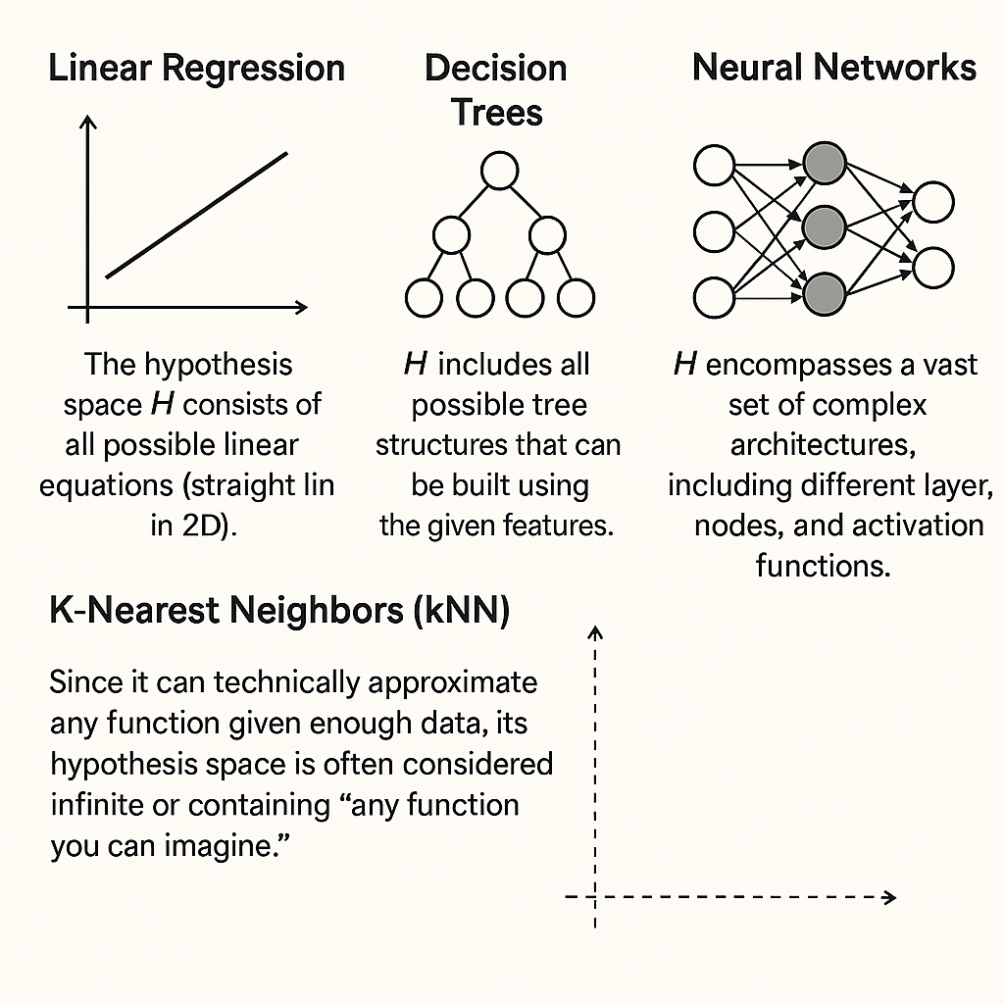

Definition and Hypothesis Space

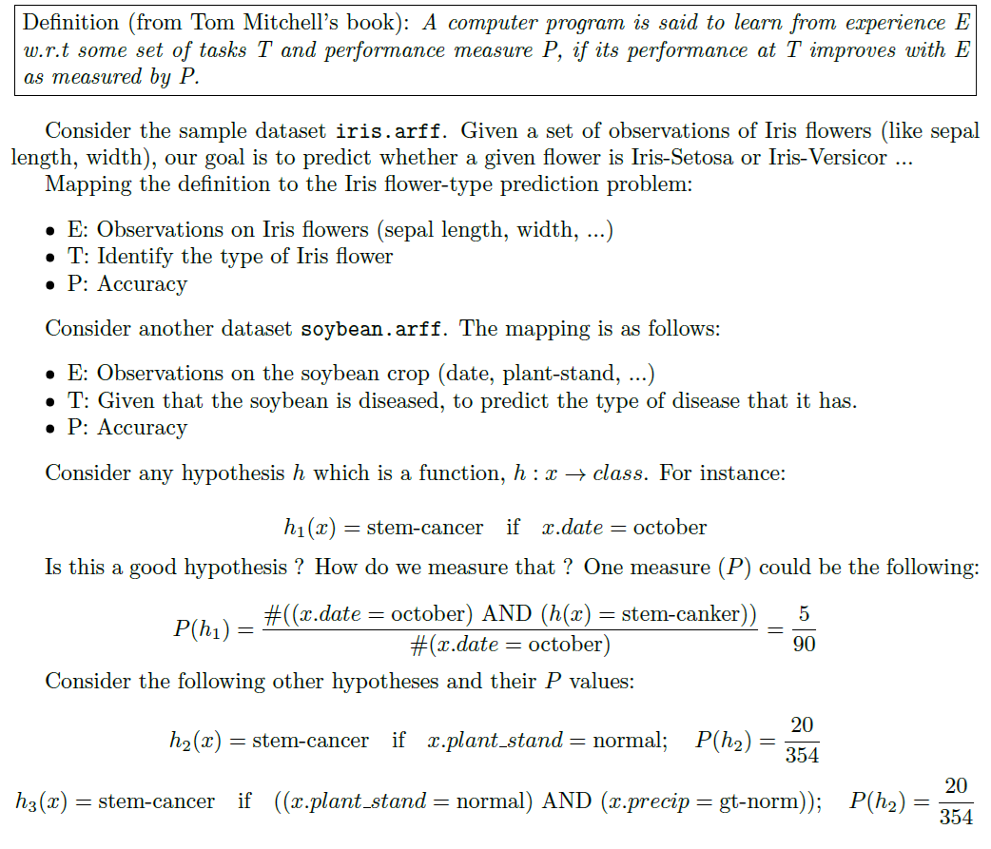

Training vs Testing vs Validation Sets

Training, validation and testing sets are three essential components in building reliable machine learning models.
- The training set teaches the model patterns,
- The validation set helps fine-tune hyperparameters and prevent overfitting and
- The testing set evaluates how well the model performs on completely unseen data.

Training: used to learn patterns
Validation: used to tune and optimize the model
Testing: used to measure final performance and generalization

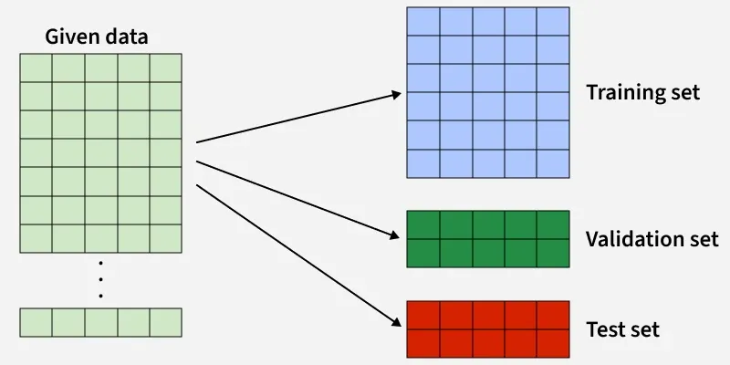

1. Training Set
The training set is the portion of the dataset used to fit the machine learning model.
During training, the algorithm learns patterns, relationships and parameters (such as weights in neural networks or coefficients in regression models) directly from this data.
The model repeatedly adjusts itself to minimize the training error using optimization techniques like gradient descent.
- The model has full access to the labels and features in this dataset.
- Learning happens exclusively on the training set.
- Performance on training data does not reflect real-world performance.
Use Cases
- Learning decision boundaries in classification problems
- Estimating parameters in regression models
- Training deep learning models with backpropagation
Advantages
- Enables the model to learn complex patterns from data
- Forms the foundation of the predictive capability of the model
Limitations
- High accuracy on training data may indicate overfitting
- Cannot be used to evaluate generalization performance

Example Code:

from sklearn.datasets import fetch_openml
from sklearn.model_selection import train_test_split
from sklearn.linear_model import LogisticRegression
import pandas as pd

titanic = fetch_openml(name="titanic", version=1, as_frame=True)
data = titanic.frame

data = data[["pclass", "sex", "age", "fare", "survived"]].copy()
data["sex"] = data["sex"].map({"male": 0, "female": 1})
data["age"] = data["age"].fillna(data["age"].median())
data["fare"] = data["fare"].fillna(data["fare"].median())

X = data.drop("survived", axis=1)
y = data["survived"]

X_train, X_temp, y_train, y_temp = train_test_split(
X, y, test_size=0.3, random_state=42
)
model = LogisticRegression(max_iter=300)
model.fit(X_train, y_train)
Output:

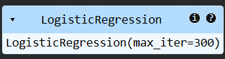

2. Validation Set
The validation set is a separate subset of data used to tune model hyperparameters and make design decisions during training.
Unlike the training set, it is not used to update model weights directly. Instead, it provides an unbiased estimate of model performance during development.
- Used during model selection and optimization
- Helps detect overfitting early
- Often involved in techniques like early stopping
Use Cases
- Selecting optimal hyperparameters (e.g., learning rate, depth of trees)
- Comparing multiple models or architectures
- Deciding when to stop training in neural networks
Advantages
- Prevents the model from being overly tailored to training data
- Improves generalization by guiding model tuning
Limitations
- Repeated tuning on validation data can still cause validation overfitting
- Reduces the amount of data available for training
Example:
X_val, X_test, y_val, y_test = train_test_split(
X_temp, y_temp, test_size=0.5, random_state=42
)

validation_accuracy = model.score(X_val, y_val)
print("Validation Accuracy:", validation_accuracy)

Output:
Validation Accuracy: 0.8010204081632653

3. Testing Set
The testing set is a completely independent subset used to evaluate the final model’s performance after all training and tuning are complete.
It simulates how the model will perform on unseen, real-world data and provides the most reliable estimate of generalization.
- Used only once (or very sparingly)
- No model decisions should be based on test results
- Represents real deployment conditions
Use Cases
- Reporting final accuracy, precision, recall, RMSE, etc.
- Comparing different finalized models
- Validating production readiness of a model
Advantages
- Provides an unbiased and realistic performance estimate
- Confirms whether the model generalizes well
Limitations
- Cannot improve the model once evaluated
- Small test sets may give unstable performance estimates
Example:
test_accuracy = model.score(X_test, y_test)
print("Test Accuracy:", test_accuracy)

Output:
Test Accuracy: 0.817258883248731

Comparison:

Aspect | Training Set | Validation Set | Testing Set
Core Objective | Learn patterns and fit model parameters | Tune hyperparameters and select the best model | Evaluate final model performance
Role in Learning | Directly involved in model learning | Indirect role (guides learning decisions) | No role in learning
Parameter Updates | Model weights are updated repeatedly | Weights remain unchanged | Weights remain unchanged
Hyperparameter Influence | Does not guide hyperparameter selection | Actively used for hyperparameter tuning | Must not influence hyperparameters
Typical Usage Frequency | Used many times across epochs/iterations | Used multiple times during experimentation | Ideally used only once
Performance Interpretation | Indicates how well the model fits seen data | Indicates whether the model is overfitting or underfitting | Indicates real-world generalization
Risk if Overused | Severe overfitting to training data | Validation leakage and biased tuning | Inflated and unreliable performance estimates
Relationship to Deployment | Indirect, supports model creation | Indirect, supports model refinement | Direct indicator of deployment readiness
Typical Dataset Proportion | Largest portion of the dataset | Medium-sized portion | Smallest portion

